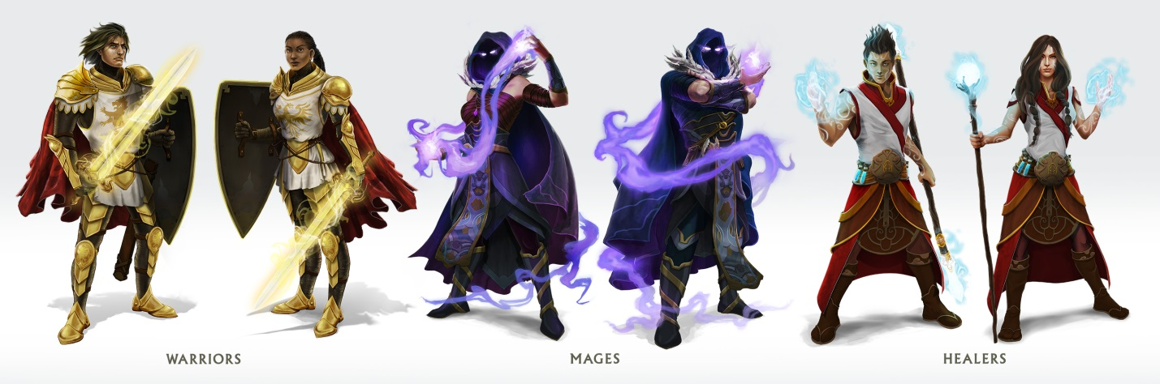
AN INTRODUCTION FOR PARENTS
Classcraft is an in-class game designed to encourage teamwork, boost participation, and increase motivation in a learning environment.
Your child is about to embark on an adventure that will change how he/she thinks about school — without ever leaving the classroom. That journey is with Classcraft, a role-playing game featuring mages, warriors, and healers that teachers and students play together.
This is no ordinary game. Students will still be learning all their normal lessons. What will change is how they connect with what they’re studying. Classcraft works as a layer over a regular class structure. Students create characters that can learn special powers and level up, and how they perform in the classroom is directly tied to whether their characters and teammates survive and thrive.
Students aren’t playing a virtual game like Minecraft or World of Warcraft. While Classcraft is inspired by those games and is browser-based, it instead turns the offline, classroom experience into the adventure. Students learn to help their peers, thereby helping their teammates in the game. They learn to participate and engage with what they’re learning — math, physics, language arts, social studies, anything — so that they can power up their character. And they’ll learn that what’s disruptive and negative behavior in class is also detrimental to their character’s success in the game.
With a little time, you and your child’s teacher should see a positive change in attitude and grade performance — real, meaningful, long-lasting benefits. Going to class is fun!

HOW CLASSCRAFT WORKS
- Students create characters that gain or lose Health Points (to survive in the game), Action Points (to use powers), and Experience Points (to level up).
- Students are rewarded in the game when they perform well during class, such as receiving +60 Experience Points for correctly answering a question.
- When a student performs poorly, their character loses Health Points, which motivates him/her to improve.
- Students do better in the game when they work together in class, forming positive relationships and learning the value of teamwork.
- Students can teach their characters “powers” that often have real-life benefits, such as more time on an exam.
- When a character loses all his/her health, it’s up to fellow students to help bring him/her back to life!
- The better students do in class and on tests and quizzes, the better their characters do in the game. It’s a win-win!

The teacher plays the role of Gamemaster, and any questions regarding the implementation of Classcraft in your child’s class should be addressed directly to his/her teacher. Thank you!

